**What Happened Part 2 (2012)**

**Before you start reading, Nox Populi has a multi-part series on what happened in 2012(parts**[**one**](https://www.youtube.com/watch?v=ad_DNgdc35A)**,**[**two**](https://www.youtube.com/watch?v=RSvwuaVm23E)**, and**[**three**](https://www.youtube.com/watch?v=Ua8iP5VOclQ)**) that you may find helpful and we recommend you watch.**

**The Email**

Those who applied early enough or followed the 'Numbers dot TK' hint were greeted with this email:

|  |
| --- |
| [**PGP**](https://uncovering-cicada.fandom.com/wiki/PGP_TUTORIAL)**-Signed Message** |
| -----BEGIN PGP SIGNED MESSAGE-----  Hash: SHA1  This message will only be displayed once.  Here is a message that has been encrypted with RSA (the Crypt::  RSA Perl module available in CPAN) :  - -----BEGIN COMPRESSED RSA ENCRYPTED MESSAGE-----  Version: 1.99  Scheme: Crypt::RSA::ES::OAEP  eJwBzQAy/zEwADE4OABDeXBoZXJ0ZXh0B4KeBtKjJ7hGKC7/zqyzxUoFDTzRuU4+TLFUrw9qDGjk  YI3fjyMn3G/w9WcfkZMGHdGRicbpTsDO3/oqmVtZpmIDY2HPOeWIZChuLfMDwT3FTUkDjQpsq390  OJ90pArd1JRxdIZtnCvnVy/vg+1MjAFH3ta+CuAwHsIY/3lGOKTin1+5M30BKh7NOQMmBcJ8/RuL  TfXMGQT01QVMeAGq6vORk3iw39KOLRU3Lcn1804G1/zd2mdFWvEMaTbu/F+7  =0KfiT9PUe6QkwJXoM36Ukw==  - -----END COMPRESSED RSA ENCRYPTED MESSAGE-----  Here is the public key used to encrypt it.  Note that it has a low bit modulus and is therefore breakable:  $VAR1 = bless( {  'e' => 65537,  'n' => '746749276957935696727019744040379028319352591778743319  7231759008957255433116469460882489015469125000179524189783',  'Version' => '1.99',  'Identity' =>  }, 'Crypt::RSA::Key::Public' );  The encrypted message is a number. Break the decryption key,  then come back to this same URL and enter the decrypted message to continue.  Each person who has come this far has received a unique message encrypted with  a unique key. You are not to collaborate. Sharing your message or key will  result in not receiving the next step.  There is a second chance to get your own RSA message and key.  Follow the "Numbers dot TK" hint to find it.  There are many fake messages out there.  Only messages signed with public key ID 7A35090F are valid.  Good luck.  3301  -----BEGIN PGP SIGNATURE-----  Version: GnuPG v1.4.11 (GNU/Linux)  iQIcBAEBAgAGBQJPEi5PAAoJEBgfAeV6NQkPV58P/0vBho7MrgWy4V4v2CGcq3gU  OfNQ+k/z3TRvJZamGqM0bJbYgaHyG6mekf4v7o68b6v7Riir3maljP0snKV6Wv6j  Ea8tzLZGonrgIJSSH4Ri3Ce9JiX4FGgNf8kY/3MahW5+TPoJGOmugfAf51XrUafH  xTGK6aa9VQoQgg4Hxig8+BQAcNOGBvrnLu2MX4e+K8877YzNhymPNQGiKa/vm/gv  BZN8S5tP9JYbSxZIU9EY5/Ny1c7Rb4uWJfmVm0EuKhx4gnVTuo7DXmZh0bcSmgk+  BPsg/mLdFVKMNaf8Znam4Lg7oGby6fg7duwNcRBtH242oDZi7Ar2PaULDeaEhVS9  Z29zFPGNpwDc8E7hecbfBzlLARkiMOApgORfBeTVP7c3p38efg+24v7Rp26J61Qf  qtppmijeO+BuytVm8XlmGLoMvL8NlCx/9ghTnaQN1hBWT/WpCPRCLC0F982zvfzC  Zhu0lPouHYdB9QYRuUcMQP03UcZNyFsdmw1epVLfL3QP9TzDoeLBopu/gHNARUzp  Icx7rqme633XCldmnLn91CMGBOMGLQGdC+z16e9zQGYuliE/SfB66Kebz2f8ZBpK  Dqw5Riu8BQAPMK1kt9evb7L/a7TZD5ISlh253ES9Tmi8/Nxot7hGMuHXFvEdajyK  qwcTZ2vegt8Tu6Hb7199  =S6GG  -----END PGP SIGNATURE----- |

After the RSA puzzle, people who submitted the correct answer to their individual RSA puzzle (each person had different "n") to the onion page received another email with a MIDI puzzle. The MIDI puzzle and solution can be found there: <http://pastebin.com/4nrDxVXk>.

If you don't understand how the cipher was solved ask in #cicadasolvers. Basicly it was substitution cipher where one tone in midi was one letter. Midi consist two songs. Second one is encrypted text from Chorus of Blakes Poem A Song of Liberty (Let the Chorus be your guide to the depths : was hint). First midi song was encrypted text players had to decrpy, with unique set of  words on the end:

verygood you have proven to be most dedicated to come this

far to attain enlightenment create a gpg key for your email address

and upload it to the mit key servers then encrypt the the following

word list using the cicada three three ero one public key sign it

with your key send the ascii armoured ciphertet to the gmail address

from which you received your numbers your words are

[unique list of words here]

garden ball house cat shore back head galon

Lurkers midi puzzle from 2012 example:

[18:40] <NiceLurk> <https://infotomb.com/oq17i> here is midi from 2012

[18:40] <NiceLurk> <http://pastebin.com/4nrDxVXk> here is how it was solved

Those who sent an encrypted PGP signed email with their words were later invited with the infamous ["leaked email"](https://uncovering-cicada.fandom.com/wiki/The_Leaked_Email).

From here, nobody knows what really happened, as the original puzzle was not very well documented in its end stages like the second puzzle was. Hopefully one day this will come to light, but after recieving this email every person that did so went completely dark, as if they had disappeared from the internet.

Nobody knew how deep the rabbit hole went, but all the solvers could agree: it was the deepest they'd ever seen.

What happened after this is mostly still not known, apart for few slips when some people told a bit more about what was going on later. Logs of those testemonies can be found on [Unfiction.](http://forums.unfiction.com/forums/viewtopic.php?p=990278" \l "990278)Legitimacy of those is not confirmed, it might be just trolling. After all, 3301 might not exist at all.

**The Final Message**

After a whole month without any word from 3301, the following message was posted on the [subreddit from the start](http://www.reddit.com/r/a2e7j6ic78h0j/) (a2e7j6ic78h0j), in a post entitled [Valēte!](http://i.imgur.com/vjuNp.jpg) (meaning goodbye, farewell). It reads as follows:

Hello.

We have now found the individuals we sought. Thus our month-long journey ends.

For now.

Thank you for your dedication and effort. If you were unable to complete the test, or did not recieve an email, do not despair.

There will be more opportunities like this one.

Thank you all.

3301

P.S. 1041279065891998535982789873959431895640\

442510695567564373922695237268242385295908173\

9834390370374475764863415203423499357108713631

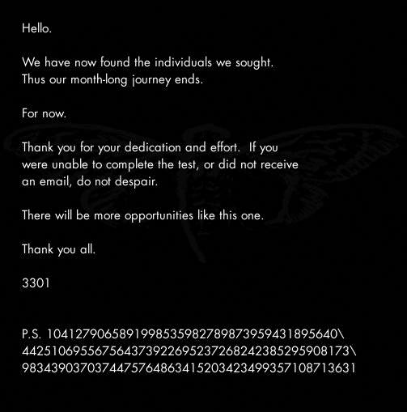This was the final message recieved from cicada in 2012 that was confirmed to be them. Mentions of 3301 popped up throughout the rest of the year, and by december everyone had forgotten about it.

Until [2013](https://uncovering-cicada.fandom.com/wiki/What_Happened_Part_1_(2013)).

Note: For any of the fake messages/speculations, please visit the appropriate pages from the main page.